Introduction to Sailing

Welcome to Sailing!

Our goal is to introduce the basic concepts of sailing to provide an enjoyable experience. We will do the following activities listed below to earn the Girls Scouts Small Craft badge, and the activities will allow each Girl Scout enough time to demonstrate and try each skill in a fun way.
1. Staying Afloat page 1
2. All Hands on Deck page 1
3. From Bow to Stern page 2
4. Permission to Board page 4
5. Hoist the Sails page 4
6. Thar She Blows page 5
7. Red Sky at Night, Sailors Delight page 6
8. Swab the Deck page 7

1. Staying Afloat: life vests

Reasons for wearing a Personal Floatation Device (PFD):
- Provides additional floatation to keep your head above water and prevent drowning.
- It’s the law. In Iowa, children under the age of 13 must wear a US Coast Guard approved PFD while on the water.

Adjust a life jacket or life vest to fit.
- Adjustments vary for each PFD, common adjustments include straps or ties.

Know if a PFD is in good condition.
- PFD’s with tears, rips, holes or that have signs of excessive wear, or that are internally wet (water logged), or are not capable of holding air should NOT be used.

2. All Hands on Deck: be ready for emergencies

Passenger falls overboard

- Everyone should yell “MAN OVERBOARD” until the skipper or captain is fully aware of the situation. Someone should keep an eye on the victim or victim’s location until recovered.
- Immediately throw additional floatation devices such as PFD’s, seat cushions, or rings overboard so that the person might be able to use them or to mark the general location of where the person fell overboard.

You fall overboard
- If you are uninjured and able to, keep an eye open for dangerous situations such as approaching boats.
- Do not try to swim to shore – stay with the boat and wait for assistance.
- Practice swimming survival techniques.
- Wave or hold something in the air to make yourself more visible to boats passing by.

The wind rises
- Head to shore or seek shelter in a leeward (loo-ard) area in the water.
- Take action on your boat to secure items in preparation of rougher conditions.
- Shift your weight to keep the boat level.

You see a storm approaching
- Stay calm and immediately head to shore and seek shelter.

The boat swamps or capsizes
- If swamped, bail out the water using a bailer, a bucket, your hands, or any device that will hold water.
- If capsized (the boat tips over into the water) try to turn the boat right side up again, then deal with getting water out of the boat. If you can’t right the boat stay with the boat (unless conditions are threatening).

3. From Bow to Stern: terms for major boat parts
Bow

- Bow – the front of the boat.
- Stern – the rear of the boat.
- Deck – the top side of the boat.
- Cockpit – the area in front of the stern and lower than the deck, where people usually sit.
- Port – anything to the left (when sitting at the stern and looking toward the bow).
- Starboard – anything to the right (when sitting at the stern and looking toward the bow).
- Windward side – the side of the boat facing the wind.
- Leeward side (loo-ard) – the side of the boat facing away from the wind.
- Lines – any rope on the boat than is less than one inch in diameter (smaller than a quarter).

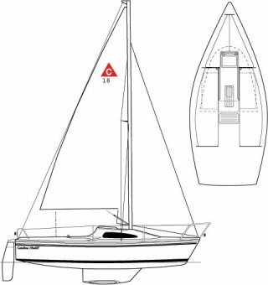
Stern

Port ⬅ ➔ Starboard

Leeward side
Windward side
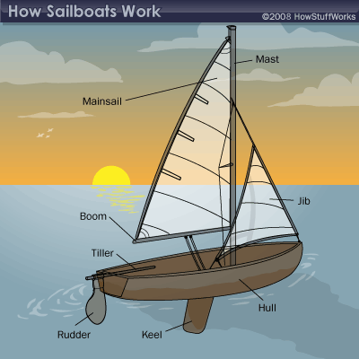

Mast

Mainsail
Jib
Boom
Tiller
Rudder
Keel
Hull

- Mast – the large, vertical pole that supports the sail.
- Jib – a small, triangular sail at the front of the boat.
- Hull – the outside body of the boat.
- Keel – converts sideways motion into forward motion and stabilizes the boat.
- Rudder – a device used to steer the boat.
- Tiller – a lever the helmsman uses to move the rudder and steer the boat.
- Boom – is the horizontal pole which extends from the bottom of the mast.
- Mainsail (main-sull) – the largest sail on the boat, connected to the mast and boom.
- Jolly Roger – the pirate flag with skull and crossbones.

Different kinds of water craft

There are four main types of water craft: sailboats, powered boats (engine), human-powered boats, and personal water craft. Can you think of some in each category?
4. Permission to Board: good manners while sailing

Board properly
  - Always ask permission to board a sailboat so people on the boat know you’re stepping on and won’t be surprised. It’s like knocking at someone’s front door.
  - Remember that the Captain of the ship is in charge and you must obey every command he or she gives to the crew – no arguing!
  - When boarding a small craft that tips easily (canoe, kayak, small sailboat) step to the center and keep your weight low, and move slowly to a seated position.

Change places safely
  - In a small boat, keep your bodies low and centered. Move slowly and carefully. The bigger the boat, the less you need to be concerned about moving around.

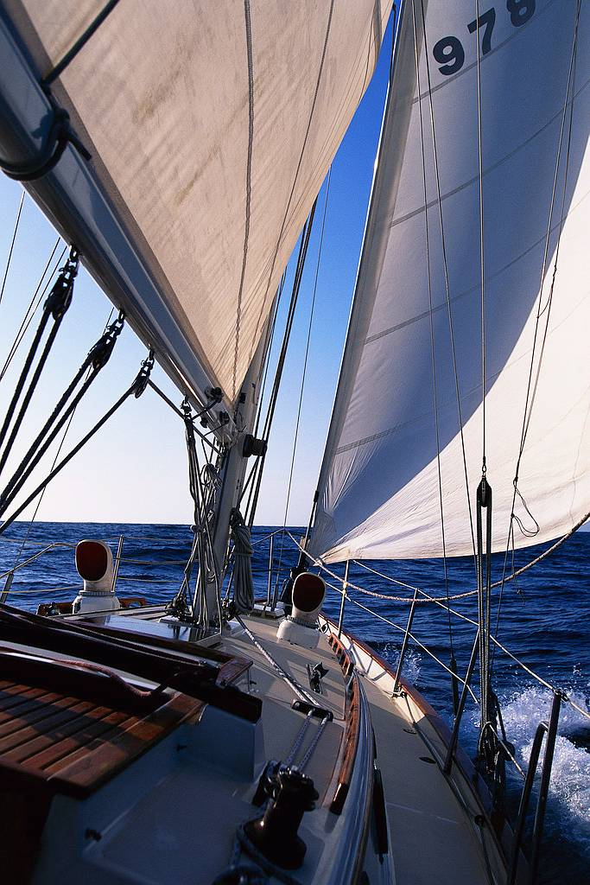
5. Hoist the Sails: using the sails and tiller to steer

Get underway
  - To “get underway” means the boat is moving under power of an engine, sail, or paddle.

Raise and lower the sail
  - You can raise the sails before departing from the dock or land, or you may raise the sails while on the water.
  - To hoist the sails means to pull on a halyard line that lifts the top of the sail into position. Once positioned, the halyard is secured so it won’t slip.

Sailing straight ahead
  - Sailing straight is a function of holding the tiller centered – this causes the rudder to maintain its position in the water.

Tack and come about
  - Tacking means to change your course direction by about 90 degrees or more.
  - You tack by turning the boat so that the bow of the boat moves through the wind which causes the sail to swing to the other side of the boat.

Speed up, slow down, and stop
  - Changing the position of a sail relative to the wind direction causes the boat speed to change. When the sail is at 45 degrees to the wind the boat will sail at its fastest.
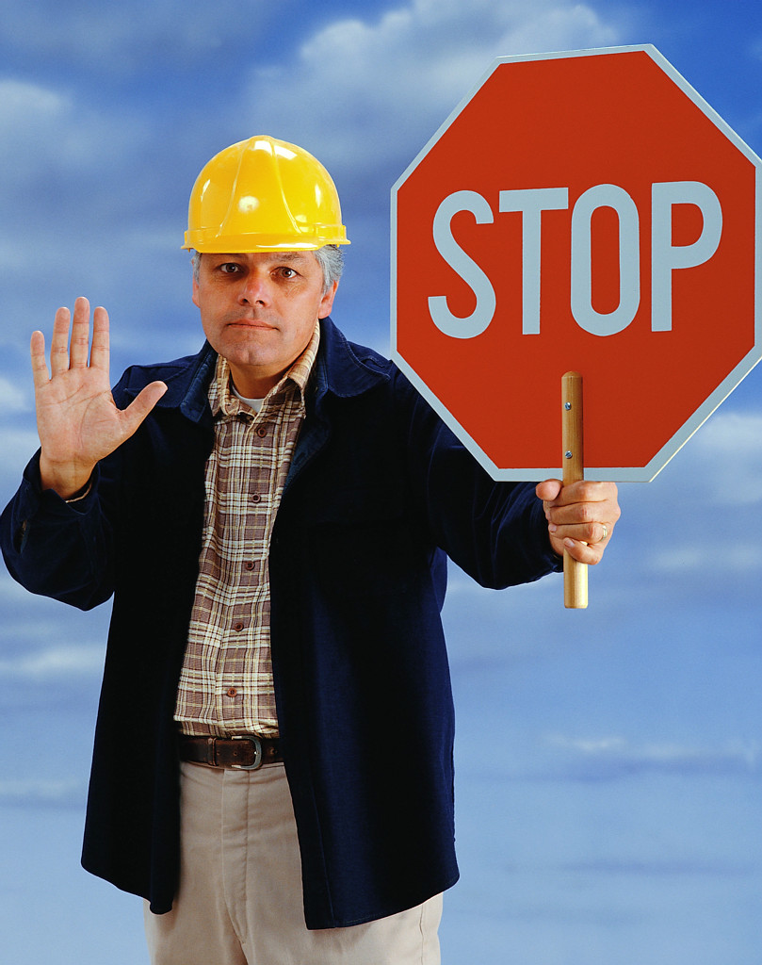
  - Easing the sail (loosening the mainsheet to let the sail out) will slow the boat.
  - Pointing the boat into the wind will cause it to slow down and eventually stop.

Dock or land
  - When docking you should be aware of wind conditions since it’s easier and often more comfortable to dock on the leeward (pronounced loo-ard) side of the dock so your sail doesn’t swinging over the top of the dock and hit people!
  - It may be permissible to “beach” the boat by nosing it up on land, but pay attention to the wind direction and position of the sails.

Secure the craft
  - To secure a boat to the dock, use the boat cleats when possible, otherwise, tie off to a secure object using an appropriate knot.

6. Thar She Blows: keeping a sharp lookout

Keep away from swimmers, divers, and people fishing
  - Boaters adhere to right-of-way rules just like cars. When heading toward each other head-on, boats generally pass each other port side to port side, just like cars on the street.
  - When two boats are moving toward each other, not head-on but at an angle, the boat to the right has the right-of-way. That means one boat has to yield to the other.
  - Powerboats must yield to sailboats, human-powered boats and people in the water, and sailboats must yield to human powered boats and people in the water.
  - Boats of all types should avoid swimmers, divers, and people fishing.

Look out for other craft, floating objects, or hazards under the surface
  - Boaters have to maintain a lookout for other boats and objects on or near the surface to avoid running into those hazards.

Use landmarks, navigational aids or navigational map
  - It’s important to use landmarks while on the water in order to safely find your way around a lake or river. Examples of landmarks are trees, buildings, beaches, etc.
  - Navigational aids consist of floating buoys, signs, and lights that mark the channel or path out to open water and back to shore.
  - Topographical navigational maps are useful for sailboats with fixed keel fins so you can avoid shallows where the boat might run aground.

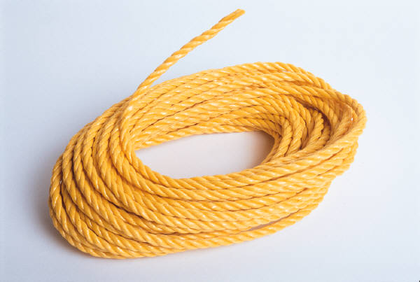
Help someone in distress, and signal for help yourself
  - Always offer assistance whenever someone is in trouble. You may need to toss someone a line or perform life-saving procedures. Resources like the Red Cross can teach you about first aid and life-saving skills.
  - To signal for help yourself you can fire a flare from a flare gun, call for help over a VHF radio or cell phone, or wave or shout to get someone’s attention.
  - All water craft should carry a whistle or other sound-producing device. Five (or more) short, rapid blasts is the warning signal for danger or distress.

Cross wakes correctly
  - When other boats make wakes (waves) near you, you may want to turn the bow of your boat toward the oncoming wakes to maintain stability.

7. Red Sky at Night, Sailors Delight: wind and weather

Weather signals and reports
  - Always check the weather forecast before you leave for a boating trip. If the weather starts to look bad while you’re on the water, then you need to head back to shore.
  - Before weather forecasts were available, sailors had to follow the advice of experiences sailors. In the old days, this was generally true:
Red sky at night, sailor’s delight: this means the setting sun is sending its light through a high concentration of dust particles. This usually means high pressure and stable air coming in from the west and good weather should follow.
Red sky in morning, sailor’s warning: a red sunrise reflects the dust particles of a system that has just passed from the west. This means a storm system may be moving to the east. If the morning sky is a deep fiery red, it means a high water content in the atmosphere, so rain is on its way.

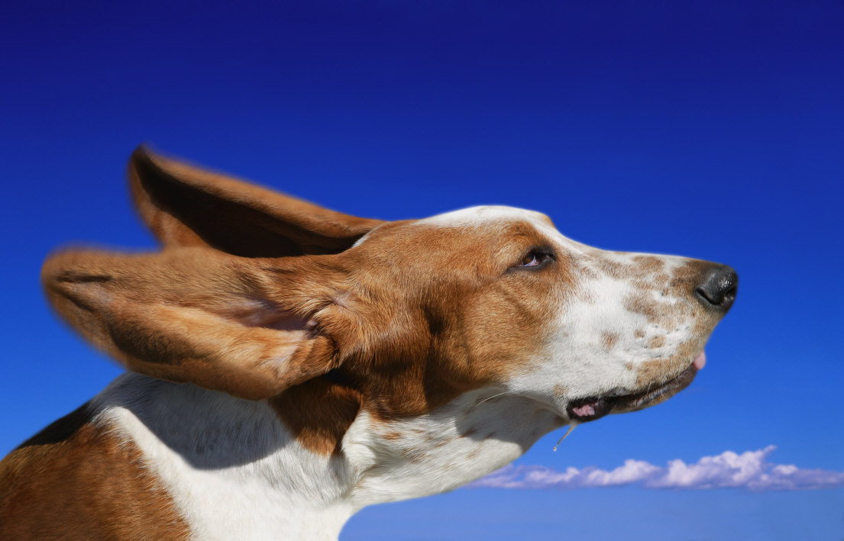
Wind direction and speed
  - Knowing the wind direction is critical when sailing. To find the wind, look at flags, smoke, trees, waves on the water, or sense the wind with your body.
  - Waves are produced by wind and powerboats. Large waves can capsize small boats or make the ride very bouncy and uncomfortable.
  - Wind speed is a big concern for sailors. The stronger the wind blows the larger the waves will be and it becomes difficult to stop sailboats from heeling (tipping) over.
  - As you gain experience you may enjoy the thrill of sailing in high winds, but for safety reasons you shouldn’t sail in weather that’s beyond your abilities.

Cloud formations and lightning
  - Storm clouds are dark which usually means changes in temperature and wind speed are likely. When you see lightning, get off the water immediately.

Water currents and dams
  - Currents are present in rivers, and dangerous currents are always present both above and below a dam. Avoid water release areas around dams at all times. On the lake side, these areas are clearly marked with buoys and in some cases are fenced off.

8. Swab the Deck: keeping things tidy

Unload or stow gear or rigging
  - Empty any onboard trash, stow or remove floatation devices, water bottles, and other equipment. Remove and roll the sails for storage, secure all loose lines, and make sure the boat is securely tied to the docks or anchored.

Wash down, bail out, or sponge off
  - In Iowa it is against the law to possess or transport aquatic nuisance species. To help protect Iowa waters, boaters may need to:
- Inspect the boat, trailer, and equipment and remove visible plants or animals.
- Drain the water from the boat onto land.
- Dispose of unwanted bait in the trash.
- Rinse or dry boat and equipment to remove or kill species that aren’t visible.

Tying knots
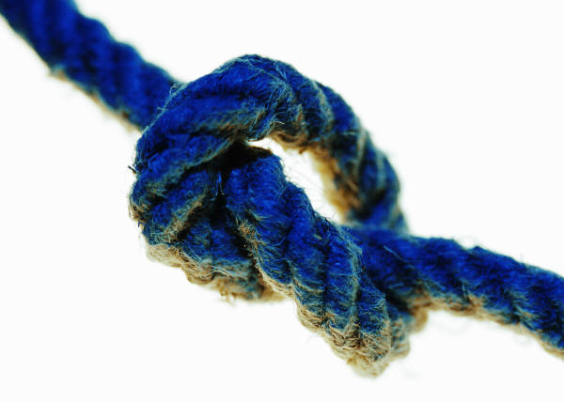
  - All sailors and boaters should know how to tie at least four basic knots, the half hitch, a rolling hitch, the bowline, and a cleat hitch. These knots keep your boat and lines secured and easy to find and undo when you’re ready.

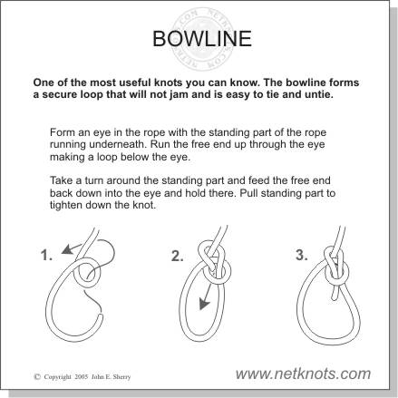

Bowline (bō-lin)

This is one of the most useful knots you can know. The bowline forms a secure loop that will not shrink or expand, will not jam, and is easy to tie and untie.
- Form an eye in the rope with the standing part of the rope running underneath.
- Run the free end up through the eye making a loop below the eye.
- Take a turn around the standing part and feed the free end back down into the eye.
- Pull the standing part to tighten down the knot.

Cleat Hitch
- Turn the line around the cleat base and bring the line over the front face of the cleat.
- Turn a figure eight pattern below each of the horns.
- Complete with a half hitch and pull tight.

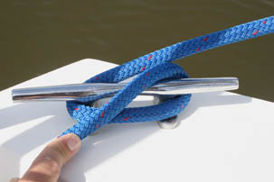
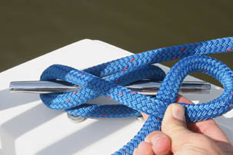
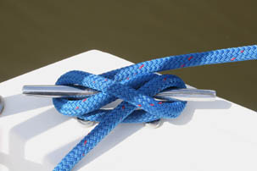

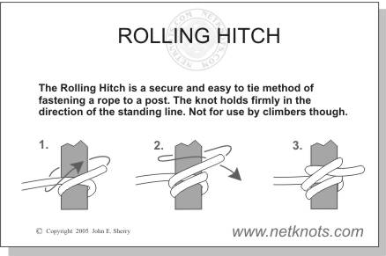
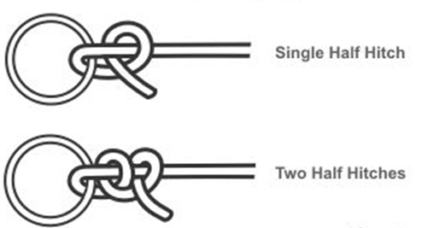

Half Hitch

The half hitch is a real knot, but it’s usually used to increase the security
of a primary knot. Use two half hitch knots to tie a rope to any object.

Rolling Hitch

The rolling hitch is an easy to tie method of fastening a rope to a post.

- Wrap two turns around the post so the line crosses over itself.
- Finish with a half hitch and pull the line to tighten.

The Beaufort Scale was developed to standardize the way people described wind speed back in 1805 by Sir Francis Beaufort, a member of the British Royal Navy.

Beaufort Scale Description | Wind speed mph | Wave height ft | Sea conditions | Land conditions
Calm | < 1 | 0 | Flat. | Calm. Smoke rises vertically.
Light air | 1 – 3 | 0 – 1 | Ripples without crests. | Wind motion visible in smoke.
Light breeze | 3 – 7 | 1 – 2 | Small wavelets. Glassy crests, no breaks | Wind felt on exposed skin. Leaves rustle.
Gentle breeze | 8 – 12 | 2 – 3.5 | Large wavelets. Crests begin to break; scattered whitecaps | Leaves and smaller twigs in constant motion.
Moderate breeze | 13 – 17 | 3.5 – 6 | Small waves, breaking crests. Fairly frequent white horses. | Dust and loose paper raised. Small branches begin to move.
Fresh breeze | 18 – 24 | 6 – 9 | Moderate waves of some length. Many white horses. Small amounts of spray. | Branches of a moderate size move. Small trees begin to sway.
Strong breeze | 25 – 30 | 9 – 13 | Long waves begin to form. White foam crests are very frequent. Some airborne spray. | Large branches moving. Whistling in overhead wires. Umbrella use difficult. Empty garbage cans tip.
High wind, Moderate gale, Near gale | 31 – 38 | 13 – 19 | Sea heaps up. Some wave foam blown into streaks along wind direction. Moderate spray. | Trees in motion. Difficult to walk against wind. Can feel swaying skyscrapers, especially upper floors.
Gale, Fresh gale | 39 – 46 | 18 – 25 | Moderately high waves, crests break. Foam blown along wind direction. Considerable spray. | Some twigs broken from trees. Cars veer on road. Progress on foot is seriously impeded.
Strong gale | 47 – 54 | 23 – 32 | High waves, some crests roll over. Dense foam blown along wind direction. Large amounts of spray may reduce visibility. | Some branches break off, some small trees blow over. Construction signs & barricades blow over. Damage to tents and canopies.
Storm, Whole gale | 55 – 63 | 29 – 41 | Very high waves, crests overhang. Big foam patches, sea looks white. Many tumbling, heavy impact waves. Spray reduces visibility. | Trees broken off or uprooted, saplings bent. Poorly attached asphalt shingles and shingles in poor condition peel off roofs.
Violent storm | 64 – 72 | 37 – 52 | Exceptionally high waves. Big foam patches cover most of sea. Spray severely reduces visibility. | Widespread vegetation damage. Many roofs damaged; asphalt tiles curl up or fracture or break away.
Hurricane | ≥ 73 | ≥ 46 | Huge waves. Sea completely white with foam and spray. Air filled with driving spray, greatly reducing visibility. | Very widespread damage to vegetation. Windows may break; mobile homes, sheds & barns are damaged. Debris hurled about.

